Special Needs Assistance Program for Social Engagement  
NEWSLETTER

August 1, 2022

# THE NEWEST SPECIAL NEEDS PROGRAM FOR ALL YOUR SPECIAL NEEDS

## 

## Our Beginnings

Message from Our President and Founder, Zachary Miller

“I have been surrounded by and supported by the special needs community. From my experiences, they are a close-knit group of individuals that deeply care for one another and show so much unconditional love and compassion without any judgment. My brother and sister were diagnosed with autism spectrum disorder at a young age, and as the middle child, I have seen all aspects of the struggles in neurodiverse adolescence. My parents and I will commonly discuss different ways to help my brother and sister with their struggles whether it be academic, work, or social. As a reminder, the simplest tasks to a neurotypical kid may be the largest wall to get around for a neurodiverse child. In one of these discussions, my mother and I were conversing about my sister Addison’s social life. Addison has always been the social butterfly of the family. She wants to talk to anyone willing to and is always looking to strike up a conversation and make new friends. In neurodiverse situations, this works great because there is no judgment, and Addison's peers understand her as does she. Unfortunately, in a more neurotypical-based world, there is more judgment toward those who do not act in the typical social norms. My sister's entire life has been spent searching for friends in school, but it is extraordinarily difficult when her peers in the classroom may not understand or accept her.

Because of my love for the special needs community, I was already considering creating a program that would allow for greater interactions between the neurodiverse and neurotypical communities. As the founder of Zachary Miller’s Tutoring for Math and Science, I wanted to create a tutoring service where neurodiverse children are tutored by neurotypical adolescents. After having that initial conversation with my mom, I realized that there is even more of a need to make a linking bridge between the two communities. More than academics and work, both communities need an avenue of connecting.

The Special Needs Assistance Program for Social Engagement, abbreviated to SNAP, was formed to give all neurodiverse individuals a stronger platform and gateway between the two worlds, to give both sides a more accessible way to meet new friends. Utilizing a matching network, SNAP connects neurodiverse individuals with other like-minded counterparts to meet for social engagement. The idea is to develop this network into an app database that allows people from both communities to connect and set up social events with each other. This new system will allow neurotypical adolescence to better understand and communicate with the special needs community. On the other hand, this helps neurodiverse children with overcoming social anxiety and impairment in addition to discovering new friendships. Overall, SNAP was created to increase the engagement, awareness, and communication between these two worlds of people and bring them together through friendship and academics for a stronger bond and a better understanding of each other.”

## Our Logo

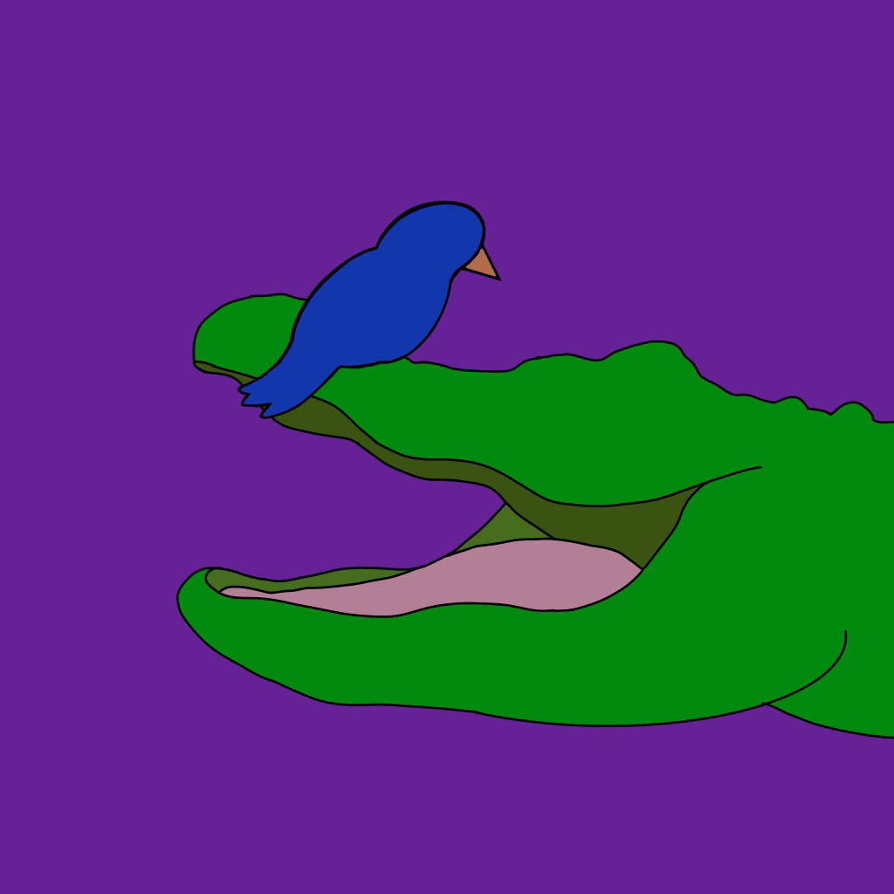

In nature, birds and alligators live in a harmonious relationship called mutualism which is the biological, symbiotic relationship where two animals benefit one another. The bird will rest inside the alligator’s mouth and pick out any of the food remaining in the alligator’s teeth. This feeds the bird and keeps the alligator’s mouth nice and clean. SNAP adapts this ideology to neurodiverse and neurotypical individuals. There is a uniqueness to our relationships, but something so unique and significant in that we can help one another and grow together. SNAP’s logo shows the love and support the two communities should share and will continue to develop and advocate.

## The SNAP Club Development

We are working on a Club affiliated with the University of Pittsburgh to help support, advocate, and work with the neurodiverse community. The goal of the SNAP Club is to create a platform that allows for the neurodiverse and neurotypical communities to interact, communicate, and collaborate more. We hope to make events to interact with the neurodiverse community targeting different neurological disorders at each meet or event. Also, we will volunteer with neurodiverse individuals in the UPMC hospitals (Pediatric and Internal) to give them someone to interact with and socialize with. SNAP Club will also inform the public about neurodiversity and educate about different neurological differences. Finally, we will collaborate with the SNAP App team to further give feedback and develop the network. Overall, the SNAP club is being made as an asset and advocate for the special needs community to create a stronger link between the neurodiverse and neurotypical communities.

## SNAP Research Sparks

SNAP research is developing its research thesis looking into new technological interventions for adolescents with Autism. With a decreasing number of interventionists and higher expenses for them, a larger niche for more accessible special needs help has grown. SNAP Research will be developing a program to aid with pragmatic communication growth helping with understanding sarcasm, social slang, connotations, and social behavior. The research will be conducted on the effectiveness of the software, its benefits, and defects versus human intervention. For more information, please feel free to reference our research abstract!

## SNAP Blasts Off

SNAP is flourishing as a special needs’ advocacy and assistance program to better support individuals in the neurodiverse community and help them in any way, shape, or form. We strive to create new methods of informing, developing, and creating a better platform for stronger communication and vocalization. SNAP is just beginning to blast off, and we cannot wait to show you what comes when we make it to outer space!